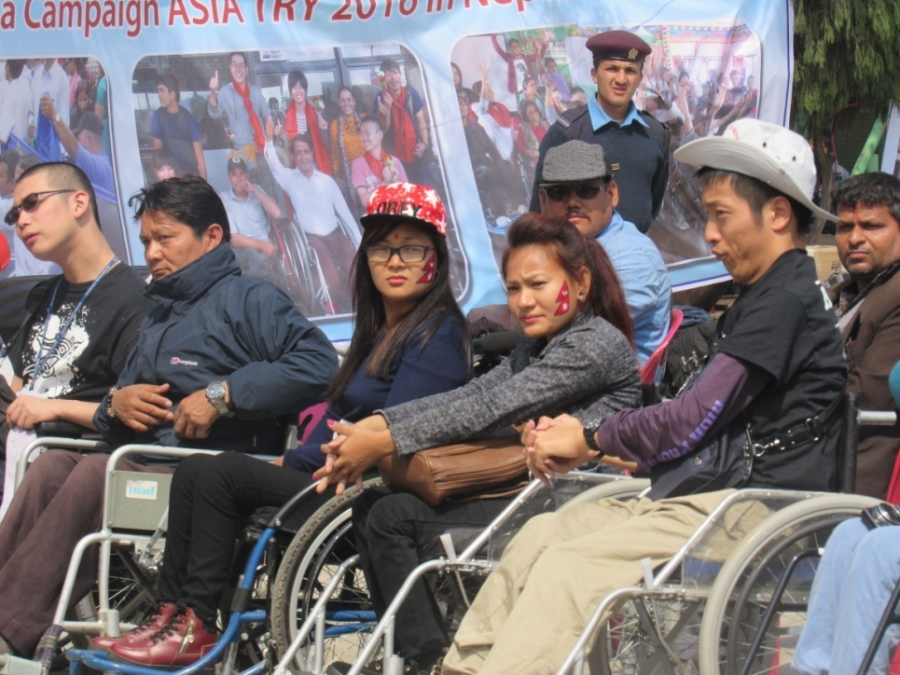
March 9, 2016, The International Mega Campaign on Accessibility: ASIA TRY 2016, is a campaign that lasts 6 days from the 9th of March to 14th of March. It is a campaign organized by The Ministry of Women, Children and Social Welfare, Independent Living Center together with other DPOs, I/NGOs, This campaign is being held in order to create awareness on accessibility and to develop a common joint strategy in order to remove the physical barriers mostly, combat discrimination, stigma and exclusion of persons with disabilities among other objectives. The event is happening in different parts of Nepal including Kathmandu and Pokhara where people travel from one place to another in the span of 4 days on a march pass in a wheelchair with consultation meeting in different places. There are 6 different groups of person with disability with assigned locations.

The event started off with Mr. Shanker Prasad Pathak, the Joint Secretary of Ministry of Women, Children and Social Welfare, giving the welcome speech and the program was launched by Mr. Nanda Bahadur Pun the Vice President of Nepal. There was a speech by the Chairperson of NFDN, Sudharshan Subedi who said talked about how existing barriers like attitudinal, physical, communication, Instutional barriers are being faced by people with disability but how physical barriers are affecting for the mobility of people with disability and how this event is focused mainly on the physical barriers.
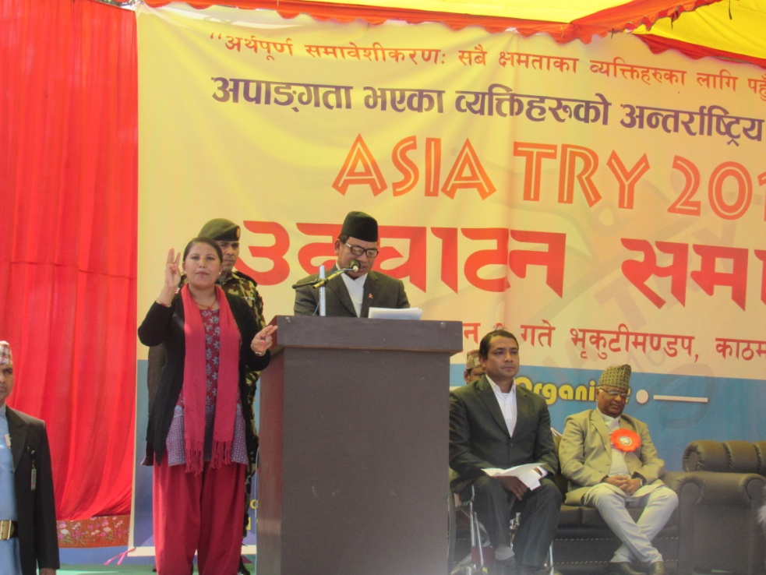
Then the president of National Federation Disability Nepal (NFDN), also spoke briefly about how the Government should have strategies to make the nation disability friendly. The Vice-President, Mr. Nanda Bahadur Pun, talked about how the constitution has some articles solely dedicated to people with disability and how during the earthquake people united for a cause and how everyone should unite for genuine causes. He talked about how people from any background and any community should all come together and unite to break both the physical and attitudinal barriers that people have about people with disability. He talked about how unity is the main thing in breaking any barrier.
The Secretary of Ministry of Women, Children and Social Work, Madhu Prasad Regmi, talked about the provisions made by the Government. He said, “The government has to give high priority and the assistive devices needed for people with disability by making reconstruction inclusive for accessibility in physical infrastructure.”
ASIA TRY is a continuous Asian campaign organized by persons with disabilities. ASIA TRY is organized periodically in different Asian countries and communities. Its concept was first conceived and implemented in Japan in 1978. Thereafter, ASIA TRY was organized regularly in six countries in Asia including Mongolia, Taiwan, South Korea, Pakistan and Cambodia. Although the campaign is run in one country at a time, people from different Asian countries come together to participate in this event and to bring about positive change. There were many organizations involved in the program today and Karuna Foundation Nepal is glad to be a part of the event which is a big step into making a progressive step towards inclusion of people with disability.
